Practical 14 :

Code :

iimport java.util.Scanner;

import java.util.Vector;

public class Vec {

    public static void main(String[] args) {

        Scanner sc = new Scanner(System.in);

        Vector<Integer> v = new Vector<Integer>();

        System.out.println("How many elements you have to enter in vector : ");

        int no = sc.nextInt();

        for (int i = 0; i < no; i++) {

            System.out.print("Enter "+i+"th Element in vector : ");

            int ele = sc.nextInt();

            v.addElement(ele);

        }

        System.out.println("The elements in vector : "+v);

        sc.close();  }

}

Output :

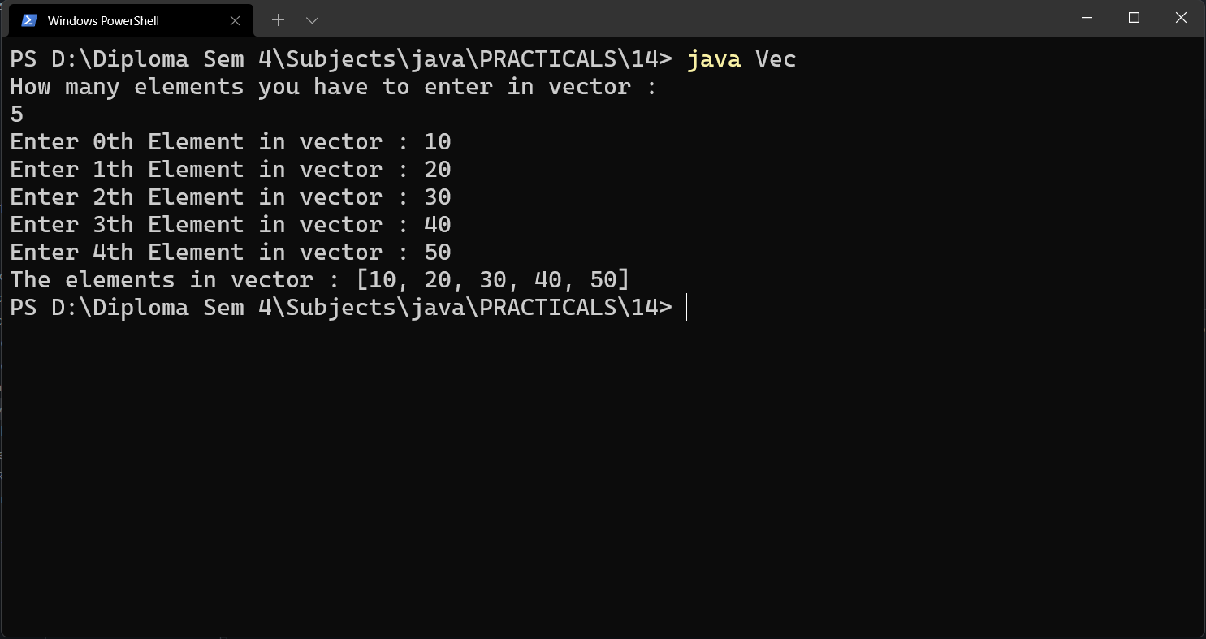

Code :

import java.util.Scanner;

import java.util.Vector;

public class Vec_Meth {

    public static void main(String[] args) {

        Vector<Integer> v = new Vector<>();

        Scanner sc = new Scanner(System.in);

        System.out.print("How many elements you have to enter in Vector : ");

        int no = sc.nextInt();

        System.out.println("Enter Elements : ");

        for (int i = 0; i < no; i++) {

            int n = sc.nextInt();

            v.addElement(n);

        }

        System.out.println("Elements in Vector are : "+v);

        System.out.println("v.capacity() : "+v.capacity());

        System.out.println("v.size() : "+v.size());

        System.out.println("v.contains(0) : "+v.contains(0));

        System.out.println("v.elementAt(0) : "+v.elementAt(0));

        System.out.println("v.firstElement() : "+v.firstElement());

        System.out.println("v.lastElement() : "+ v.lastElement());

        System.out.println("v.indexOf(0) : "+v.indexOf(0));

        v.insertElementAt(0, 0);

        System.out.println("v.insertElementAt(0, 0); : "+v);

        v.removeElement(0);

        System.out.println("v.removeElement(0); : "+v);

        System.out.println("v.size() : "+v.size());

        sc.close();

    }

}

Output :

